Hidden Nature (Chisei)

"A horizon where the perspective was not three-dimensional but multidimensional in bright shades of yellow, gold and white contours. Geometric shapes in the same shades moved elegantly like a dance where the arms completed perpendicular circles in a gentle rhythm." Rodrigo Dutra, 2015

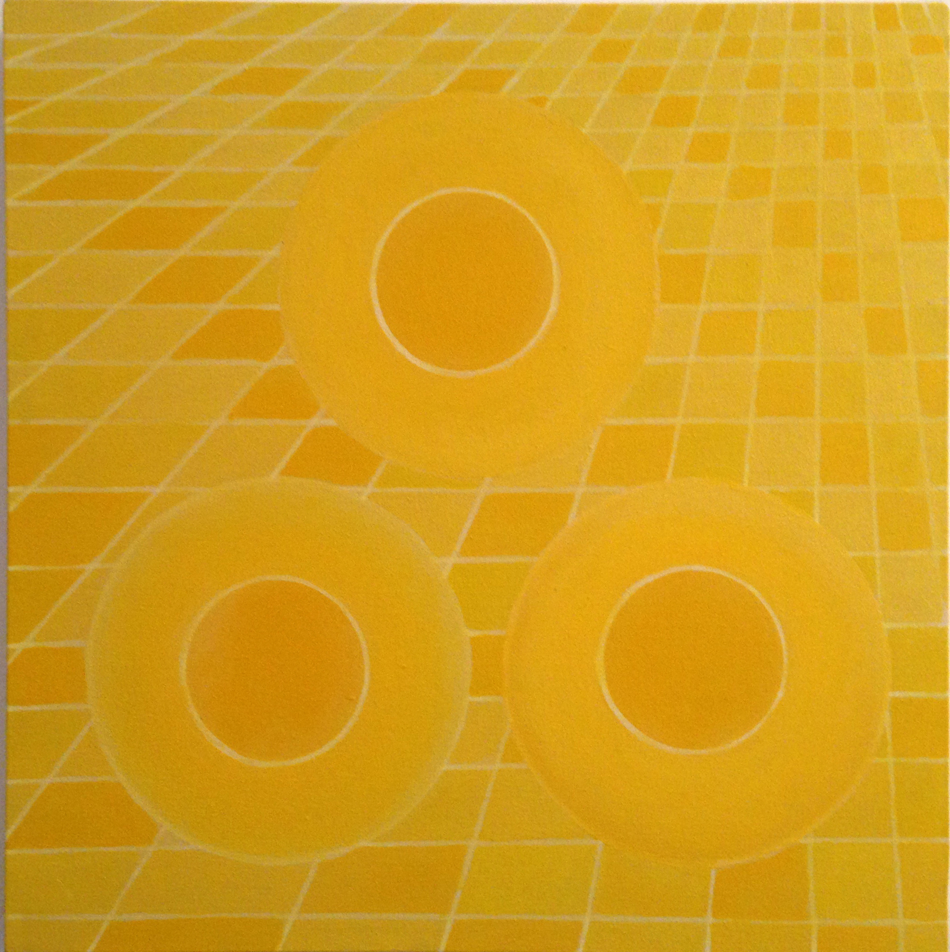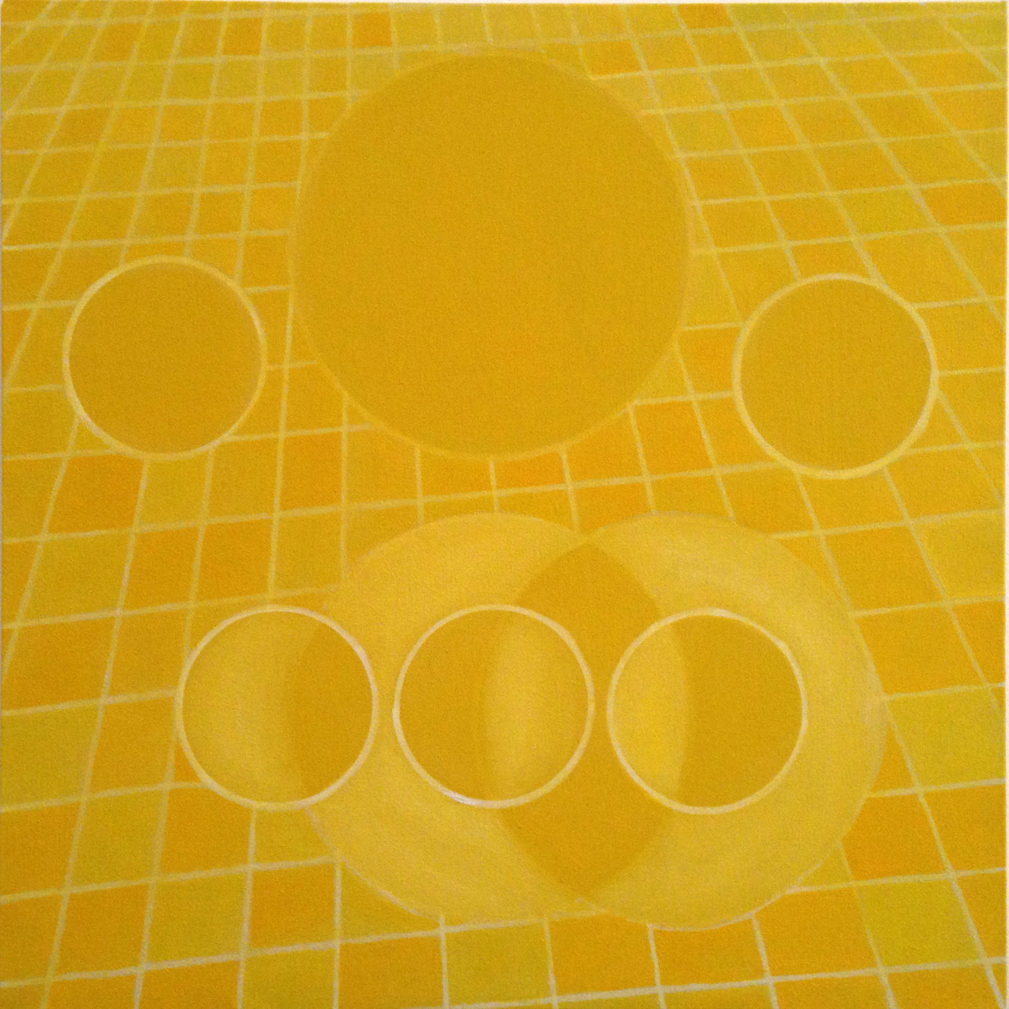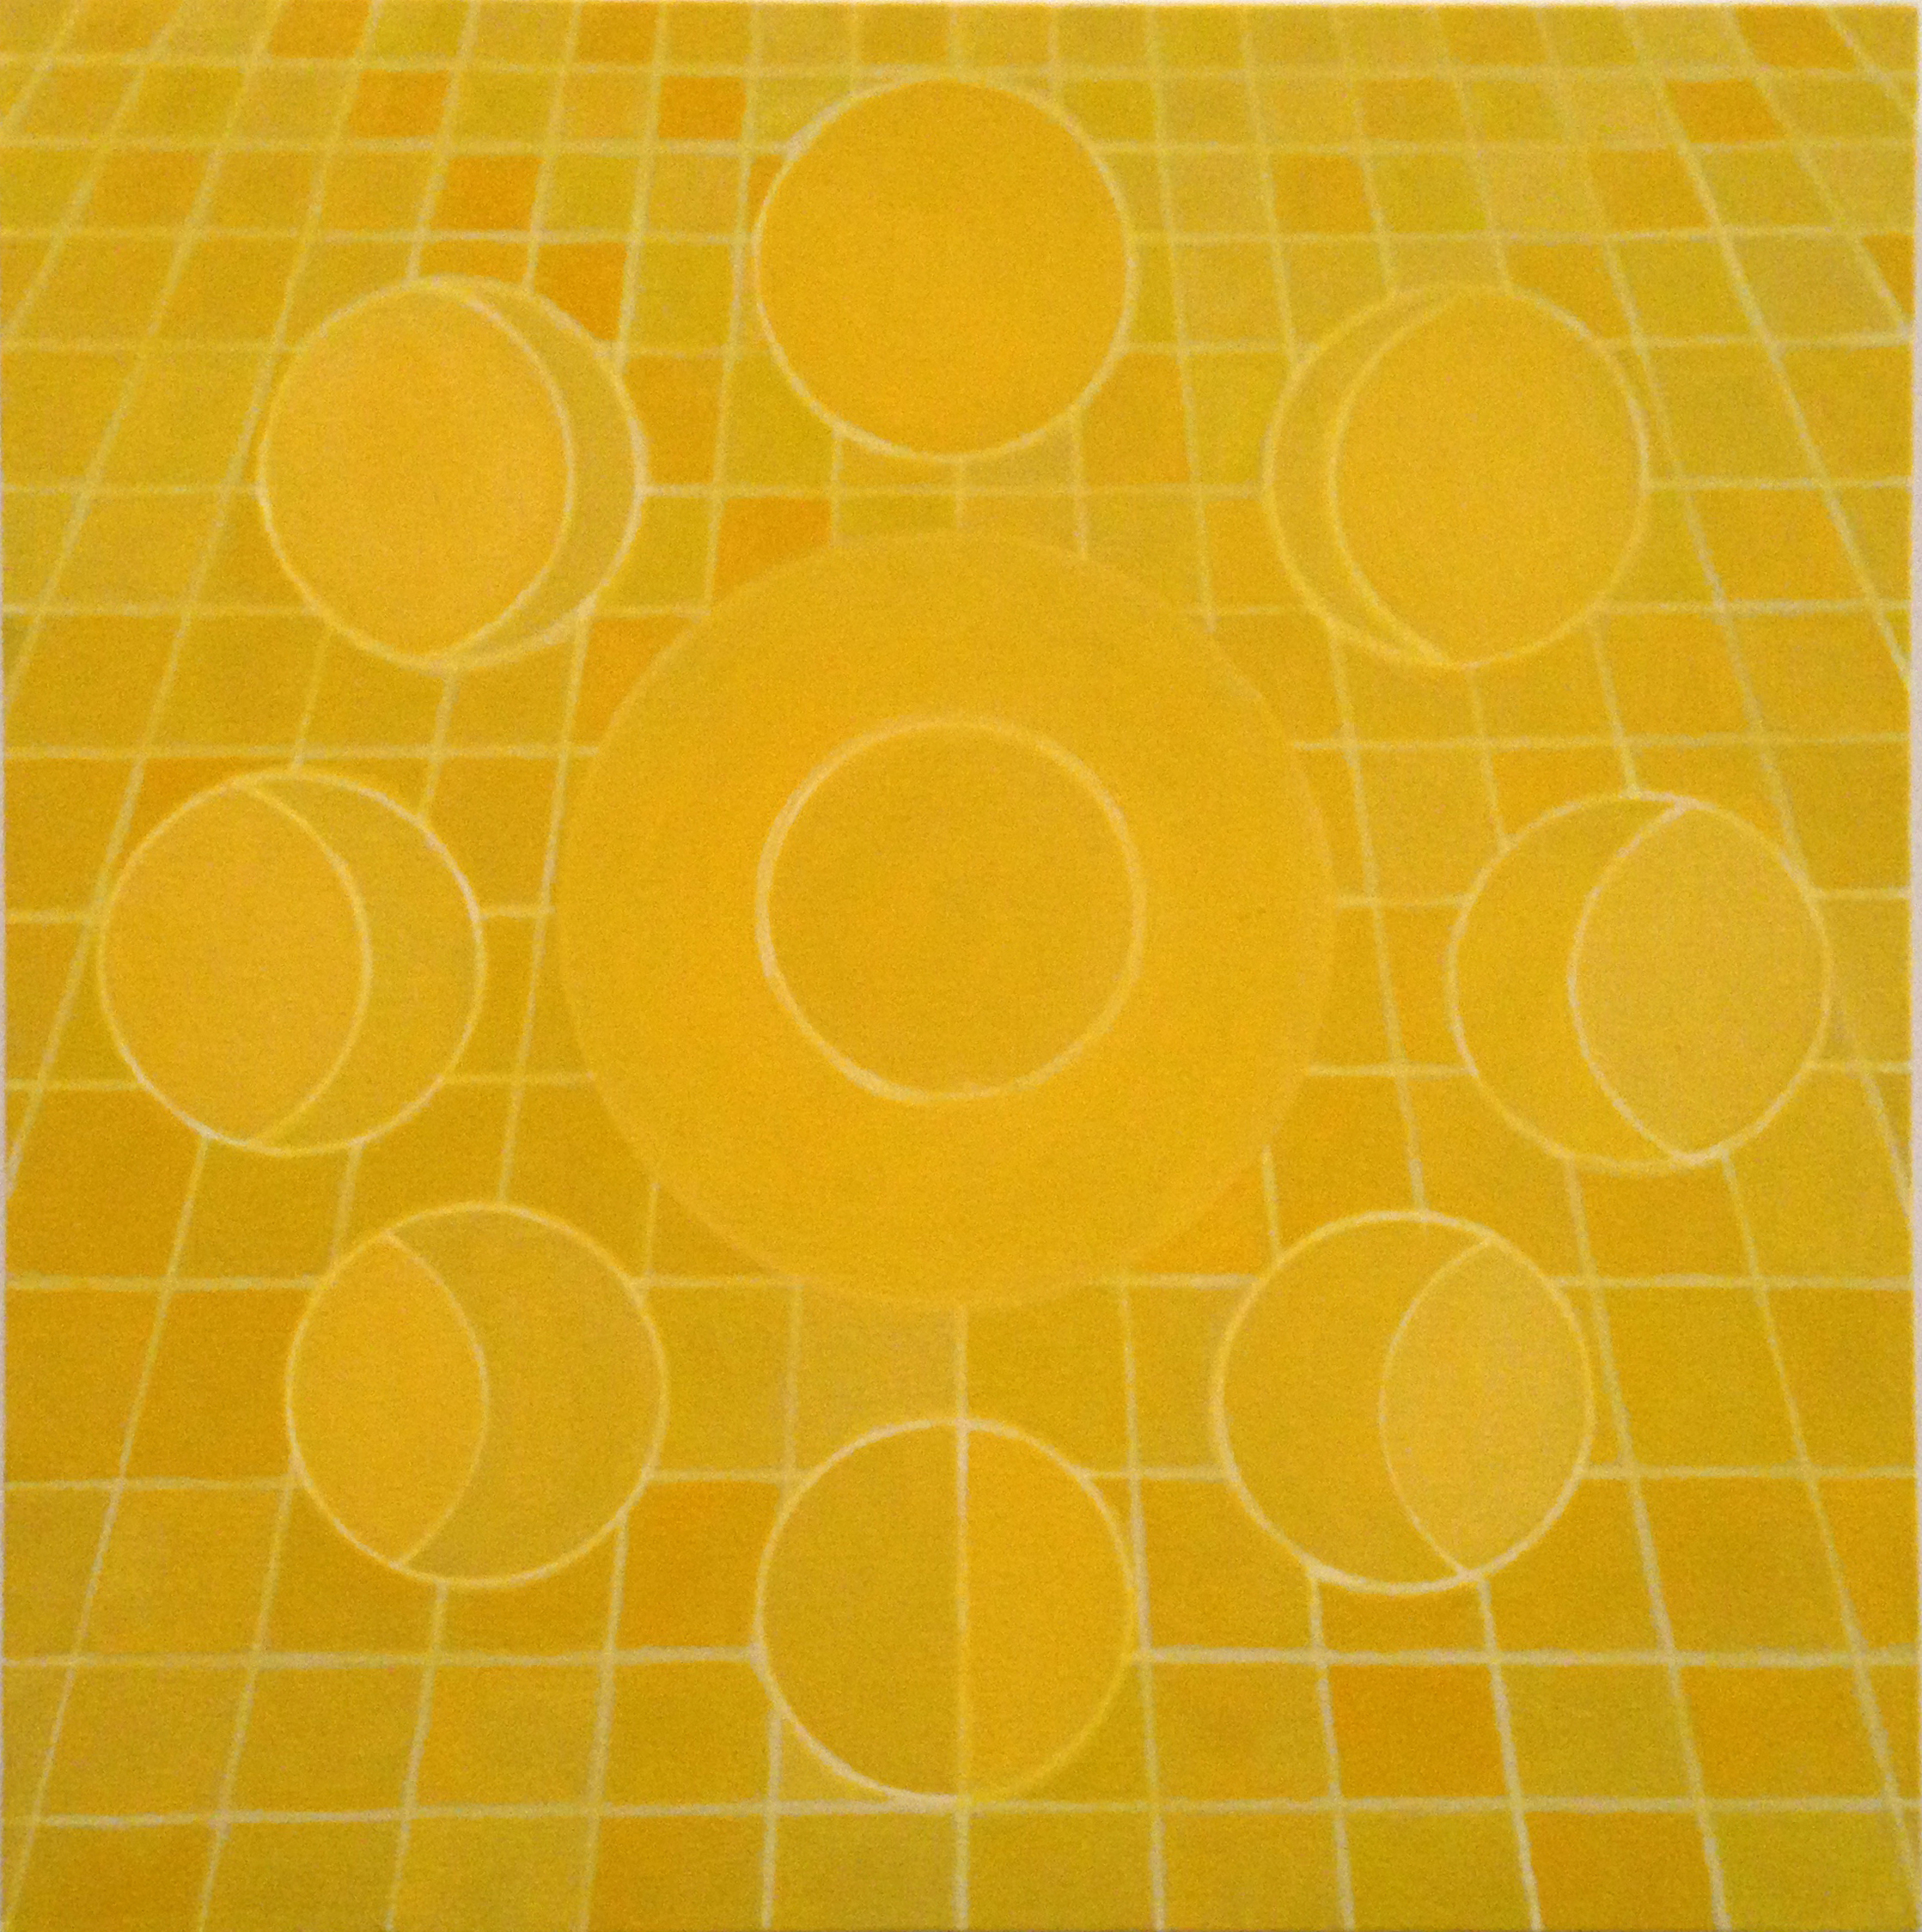
Reino Abstrato VI, VII, VIII, 2016. Oil on canvas xxxxxx

In The Cosmic Serpent (1995) and Intelligence in Nature (2005) the Swiss-Canadian anthropologist, writer and activist Jeremy Narby acknowledges the usage of ayahuasca and the resulting visions as a possible and legitimate method of communicating with other beings and hence of knowledge generation. He compares consuming the hallucinatory brew with a microscope, considering it yet another way of understanding nature. Narby discovered that in line with the Japanese notion of chisei, which is based on the belief that stones and wood possess some kind of intelligence, shamans in the Amazon know to communicate with the spirits of plants, rivers, the earth, moon and sun.

Narby’s unorthodox research earned him a fair amount of criticism. Nevertheless, while staying in the Peruvian Amazon Rodrigo García Dutra (Rio de Janeiro, 1981) too got convinced of the existence of consciousness in all beings. “Animals, plants and matter are encrypted through a secret language that likes to hide. This intelligence does not show often. A human being must be in a deep state of consciousness to understand what that intelligence is communicating or rather, how it is working”, Dutra explains. The artist spent a month with the indigenous Shipibo people and took part in several ayahuasca sessions. These experiences enabled him to understand the world in a new holistic way but also strongly influenced his artistic practice. According to Dutra, “It was an aesthetic experience. For me the greatest contemporary artist is ayahuasca”.

The quote cited in the beginning reflects, or rather reveals a glimpse of, one of the visionary experiences Dutra had, on that strongly influenced the exhibition. Dutra is not the first artist who draws inspiration from the usage of ayuahasca. The Peruvian Amazon has a rich tradition of visionary art of which the late Pablo Amaringo (1938-2009) and Rember Yahuarcani (1985) are two of the most prominent artists. Their paintings however remain figurative and are furthermore characterized by intense color combinations and psychedelic compositions. Dutra’s Abstract Realm and the Blue series on the contrary are determined by serene groupings of soft shaped and yellow toned spheres. The circles may refer to cells, the shape of our irises, the sun, or even to planetary systems but also seem to indicate a time measuring system. The shapes in the Abstract Realm series are placed against a background of a playful and slightly irregular grid pattern, creating a perspective that we know from Dutra’s Abstract Ground series (2014). Although the circles occasionally intersect, allowing other color accents to appear, the overall composition is balanced, calm and flowing.

The series of drawings range from figurative, identifiable impressions of Dutra’s stay with the Shipibo to what seems to be introspective, abstract indications of emotions, all in white, yellow, golden and earthy tones. The series seem to indicate a sequence, a process towards pure yellow light dissolving all distinguishable forms and physical matter.

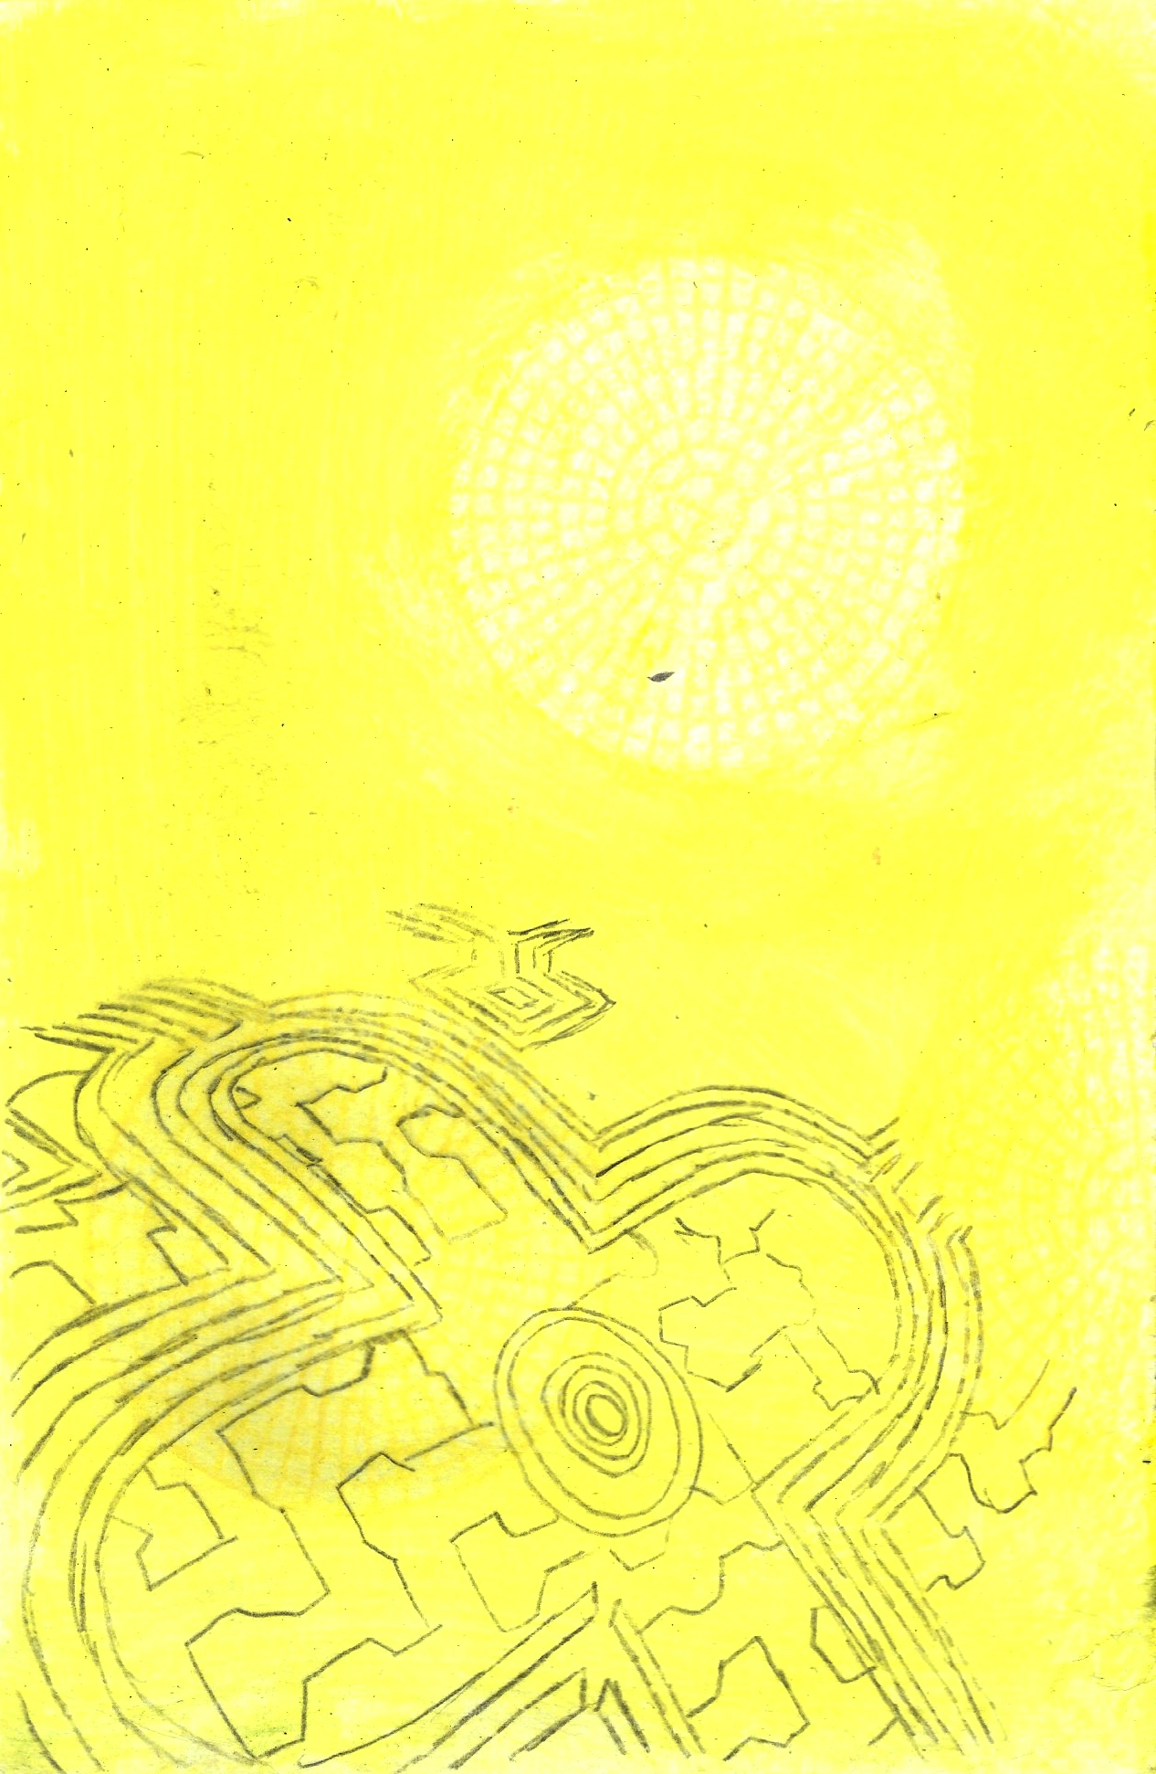
Hidden Nature IV, V (2016)

The mesmerizing video Fluidics II (2016) combines fragments of swirling, cascading water with computer animations featuring the grid, changing perspectives, spinning suns, moons, planets and the light in a vertiginous pace. Radiating an abundant, everlasting kind of energy. The independent yet related subtitles derive from an interview with the neo concrete artist Lygia Pape (1927-2004) who like Dutra felt a great fascination for the color yellow and light.

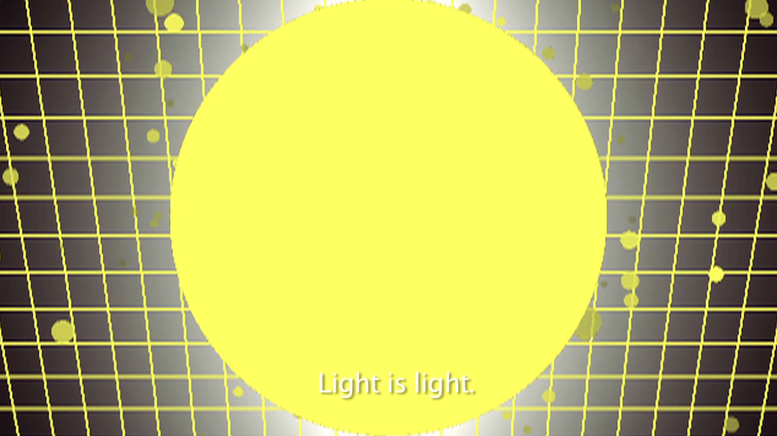
Still from Fluidics II, 2016

In Shandeinaum (2016) we recognize sounds that Dutra recorded in the Amazon. The meditative sound piece starts with a deep, slow rhythm and sounds of bird and insects to slowly unfold in a swelling mysterious melody. A choir pronouncing the mantra-like words ‘shan – de – ina – um’. Although the mantra is meaningless, its rhythmic repetition evokes a relativating and calming effect. The work has been created in collaboration with Dutra’s brother Matheus Garcia Dutra.

The paintings remind of the compositions by the Swedish artist Hilma af Klint (1862-1944) and the Czech František Kupka (1871-1957), who tried to reach a higher reality as well. Also the formal, geometrical principles of neo concrete art from artists such as Pape and Ivan Serpa (1923-1973) come to mind. Dutra feels strongly connected to the neo concrete practices on a content level as well. In line with Pape’s practice Dutra intends to represent an archetypical essence, to formulate a set of visual elements that allude to a universal symbolism. Both in the work of Pape and Dutra the color yellow and light play a fundamental role. In the emblematic work Book of Creation (1959) for instance Pape maps the creation of the world in sixteen elementary icons that are meant to resonate with a ‘collective unconsciousness’, to speak in Jungian terms. One page consists of a yellow square with a small opening in the middle trough which the light should shine.“ It is the information as it’s full potential. Light is light. There is no explanation”, she declares cryptically in the documentary Neoconcretism.

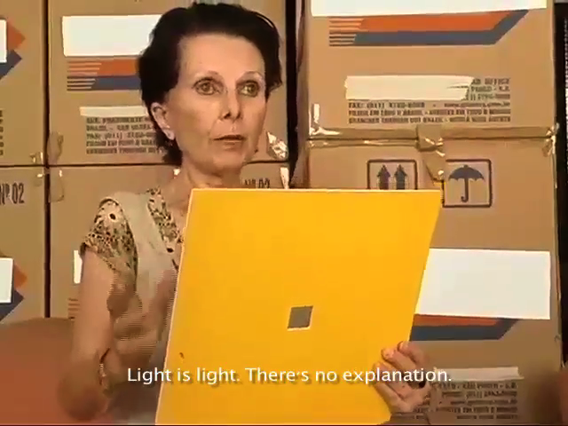
Lygia Pape explaining the Book of Creation (1959)

Both the neo concrete artists and Dutra base their work on information drawn from the subconscious. While Dutra ‘found’ a visual vocabulary in his visions, - which in a way places him closer to the surrealist tradition - the neo concrete artists drew inspiration from the expressions of the mentally ill.

This particular legacy
Another, though coincidental, relation between Dutra’s work and the neo concrete legacy

To Dutra it all came together when staying, by chance, in the former house of the Brazilian psychiatrist Nise da Silveira who had founded the Museum of Images of the Unconscious in Rio de Janeiro therefore was a place they visited. This museum was founded by the, a student of Carl Jung, and focused on the art of psychiatric patients, or outsider art.

After the Amazon I move to the city I born, Rio de Janeiro and spent two months working in a studio in Santa Teresa which happened to be the house where once lived Dr. Nise da Silveira , a Brazilian psychiatrist, student of Carl Jung and founder of the Museum of Images of the Unconscious.

Hidden Nature relates to paintings, drawings, a sound piece and a video he attempts to convey the hardly describable visions into interpretable visuals and sounds.

Hidden Nature stems from the visionary experiences Dutra had in the Amazon.

Hidden Nature thus on the one hand is based on Dutra’s experiences in the Peruvian Amazon, which enabled him to understand the world in a new way, and on the other hand it stems from the legacy of the neo concrete artist.

////////////////////////

Hidden Nature - Rodrigo Dutra

works in the show:
1 mp3 sound piece
1 video
3 paintings (yellow)
8 paintings (blue)
5 drawings
+ 1 pdf publication with pictures and texts

for the comprehension of the theme in relation to the 'neo-concrete' movement in Rio de Janeiro where Lygia Pape, Lygia Clark, Helio Oiticica and others were looking into mad people works at Nise da Silveira's Museum of Unconscious as source of inspiration ( also the relation to the yellow color). I will try to translate the video and create subtitles for better understanding.

Then I saw this film where she describes with her own voice the essence of her creations. I particularly love the way it’s so simple and at the same time so universal, speaking of geometric forms and relating them to the sun, the earth, the yellow color.

I relate to Lygia Pape, through Carl Jung archetypes, dealing with ancestral images of the unconsciousness.

I also adapted the translation I did from Lygia Pape’s description of book of creation in that video “Neoconcretes” to my video “Fluidics II” as an on going conversation.

Creation of the world sin palabras, infinite of structures

///////////

Both scholars are open to radical assumptions and think beyond the traditional scientific paths. Just because we cannot proof or understand it, it does not mean it is not valid or should not be taken seriously seems to be their credo.

The relation between art and the unknown, unexplainable or spiritual for that matter is perhaps a more explored field.

yet the components seem to allude to a universal symbolism – an almost Jungian set of archetypes, inherent and common to all existence.

Nise da Silveira’s Museum of Images of Unconsciousness were visited by the Neocretes many times as research. They were interested in the Supra Sensorial (not in LSD or other psychedelics as Ayahuasca ): . Recently Haroon Mirza presented a show at Pivô where Lars bang Larsen talks about those relationships. I'm sending you the video where they talk about this.

Although it is impossible to represent such experiences, the paintings presented do trace the vision. Nevertheless

We increasingly become aware of the fact that our way of treating our environment is not sustainable,

the modern distinction between man and nature is crumbling

and our western arrogance has proven to be unaffordable.

The blue series are based on the same vocabulary, although they miss the grid perspective, appear less balanced and contain more contrast.

With the risk of loosing his credibility

The dawn of the anthropocene and our growing awareness of the need for a more equal relation with our environment lead to a willingness to consider other, perhaps less conventional, theories on nature. In How Forests Think. Towards an Anthropology beyond the Human (2013) by the Ecuadorian anthropologist Eduard Kohn for example, the still dominant modern and Western principle that we are distinct - and superior - from other life forms is deeply questioned. Kohn attempts to ascribe scientific validity to complex, sometimes improvable communication systems and forms of intelligence present in forests and related indigenous knowledge.

which is actually not only a book but also a sculpture that ‘reads’ as poem and may be manipulated by the spectator,

Among the main ideas that caught me is the concept of Japanese intelligence (chi) which greatly resembles that of the Amazonian shamanism where any creature and elements of nature have intelligence.

After the Amazon I move to the city I born, Rio de Janeiro and spent two months working in a studio in Santa Teresa which happened to be the house where once lived Dr. Nise da Silveira , a Brazilian psychiatrist, student of Carl Jung and founder of the Museum of Images of the Unconscious .

Kohn’s approach contrasts with the Western perception on nature as an exploitable resource, a decor to enjoy or a subject to study.

he examined the way a jaguar regards us and seriously explored how Amazonians interact with their (non-human) surroundings. With this unconventional perspective -
The parliament of things, forest law etc
At the same time a growing willingness to accept (or maybe we should say a less resolute rejection) of alternative beliefs, or realities, seems to grow.

The modern, western distinction between man and nature is definlite

, to this shift of paradigm sketched above, in the sense that it stems from a more holistic and experienced based a point of view.

Hidden Nature draws inspiration from
Livro da Criacao (book of creation) Lygia Pape maps sixteen moments of the creation of the world. The work, which is actually not only book but also a sculpture, ‘reads’ as a poem and invites the spectator to physically interact with it, is Pape’s interpretation of

[Book of Creation] is emblematic of the early Neo-Concrete works. The work consists of sixteen unbound cardboard "pages."

The pages are 12 x 12 inches each and feature abstract images that are supposed to signify a significant moment in the creation of the world, such as the recession of water, the discovery of fire and agriculture, hunting, and navigation.^{[12]} Each page is additionally accompanied by a title that gives sequence and meaning to the book. However, many of these titles function more as poetic lyrics, making the interpretation of each page difficult and the sequencing hard to follow.

The viewer is meant to participate with the artwork, manipulating the book and interacting with the pages up close. As the viewer handles and assembles each page, he or she is meant to interpret the lyrics and project their interpretation onto the abstract page. The participant's perception of the abstract page is meant to shift after he or she reads the accompanying lyric and projects it onto the abstract page. Thus, the idea of creation is twofold: the book itself is a narrative of the creation of the world, but it also narrates the creative process of the participant as he or she unfolds the meaning of the work.^{[12]}
As a Neo-concrete artist, Lygia Pape's Livro da Criacao [Book of Creation] synthesizes reason and emotion. The participant is meant to have a phenomenological experience by handling the book. Each reading of the work might be different based on the individual's experiences. As Lygia Pape noted, "It's important to say that there are two plausible readings: for me it is the book of the creation of the world, but for others it can be the book of "creation." Through each person's experiences, there is a process of open structure through which each structure can generate its own reading."^{[12]}

The imagination of nature is far, far greater than the imagination of man, Richard F

seem to go hand in hand with an interest in

all point towards a crumbling (western, modern and artificial) distinction between man and nature. It’s a development that seems to go hand in hand with the current popularity of

Research approaches as adopted by the Ecuadorian anthropologist Eduard Kohn who wondered how a jaguar regards us, and opted
He adopts a trailblazing approach by wondering how a jaguar regards us

indicate a new

questions the still dominant Western principle that we are distinct (and superior) from other life forms. and by exploring how Amazonians interact with their (non-human) surroundings for example

We raken er steeds meer van doordrongen dat

He adopts a trailblazing approach by wondering how a jaguar regards us

interaction

Not so long ago I read about the ‘wood-wide-web’. Trees and plants appear to be able to communicate via an extensive underground fungal network. A fascinating phenomenon. It makes you wonder about future discoveries.

In How Forests Think. Towards an Anthropology beyond the Human (2013) the Ecuadorian anthropologist Eduard Kohn questions the still dominant Western principle that we are distinct (and superior) from other life forms. He adopts a trailblazing approach by wondering how a jaguar regards us and by exploring how Amazonians interact with their (non-human) surroundings for example.

Indigenous Japanese, Indonesian and Amazonian cultures however are rooted in a more holistic worldview and share a common believe that rivers, stones, flora and fauna are all spirited and possess a certain intelligence for a long time.

During a residency in the Peruvian Amazon Rodrigo García Dutra (Rio de Janeiro, 1982), got acquainted with

meditation, yoga and medicinal plants) with participation of a indigenous Shipibo couple.

There were 8 ayahuasca ceremonies with them within one month. At the same time I read two books written by a Canadian-Swiss anthropologist: Intelligence in Nature and The Cosmic Serpent by Jeremy Narby. Along with the ceremonies (which were the most incredible thing I ever experienced) these books accompanied me throughout the process. Among the main ideas that caught me is the concept of Japanese intelligence (chi) which greatly resembles that of the Amazonian shamanism where any creature and elements of nature have intelligence. After the Amazon I move to the city I born, Rio de Janeiro and spent two months working in a studio in Santa Teresa which happened to be the house where once lived Dr. Nise da Silveira , a Brazilian psychiatrist, student of Carl Jung and founder of the Museum of Images of the Unconscious .

and in the revelation of covert structures such as the communication between trees (‘the wood wide web’) or the collective intelligence of termites all

Hidden Nature

Hidden Nature reflects the current interest in

After the The Secret Life of Plants (1973)

//////

I saw the Book of Creation by Lygia Pape at the Serpentine in London when I was still in college. Then I saw this film where she describes with her own voice the essence of her creations. I particularly love the way it’s so simple and at the same time so universal, speaking of geometric forms and relating them to the sun, the earth, the yellow color.

About the yellow color as information there’s an astonishing BBC documentary on youtube describing the specificities of the golden yellow colour: https://youtu.be/pkLn_4xBaMk . One of the interviews describes a process of an artist meditating on yellow. That’s what I did in one of the ayahuasca ceremonies in the Amazon, without knowing I was led to layers and layers of olden civilizations, buildings and geometric forms, architectures of light, high and higher until I arrived at the empty dark void. From there I understood the unity of it all, as a creation of our supreme consciousness.

Many visionary artists affirm that it’s impossible to represent the experience. I agree. The paintings can be traces of that experiences, symbols or key images to recollect it in my own memory but what I do is an artistic practice that are in touch of those realms and have a life on it’s own.

I relate to Lygia Pape, through Carl Jung archetypes, dealing with ancestral images of the unconsciousness. The circle or sphere has been present in the history of humanity since the early phases of evolution. We have been following circular forms in the sky like the sun and the moon. Coincidentally or not that is the form in our eyes as we look to each other and here comes our primal relationship to this geometric form and how it influence us. I also adapted the translation I did from Lygia Pape’s description of book of creation in that video “Neoconcretes” to my video “Fluidics II” ( I will send it to you guys soon ) as an on going conversation.

Nise da Silveira’s Museum of Images of Unconsciousness were visited by the Neocretes many times as research. They were interested in the supra sensorial* (not in LSD or other psychedelics as Ayahuasca ). Recently Haroon Mirza presented a show at Pivô where Lars bang Larsen talks about those relationships (art and psychedelics) : https://vimeo.com/174674200

Shandeinaum, the sound piece, is a collaboration with my brother Matheus Garcia Dutra, using sounds I recorded in the Amazon and special effects he created. He added this fictional mantra Shan – de – ina – um that is meaningless but performs as a mantra, a rhythmic repetition of syllables evoking peace, love and stillness.

The yellow paintings, the sound piece, drawings and video should be in the gallery space (garage) and the blue paintings can be somewhere outside, in the entrance hall or somewhere else.

Thank you so much for being part of this. I’m very happy this is coming out a year after being there. Please, don’t hesitate to ask me more questions. I take sometime to answer because I’m away from home.

slowly but surely changing our perspective on nature. Whereas the western world we are used to enjoy nature, to study its phenomena and to generally regard it as something we own and are allowed to exploit.

Secrets serve a purpose for a certain time and reason. The time will come and those secrets would be revealed.

Japanese and Amazonian cultures are connected by the idea that everything has intelligence. Animals, plants and matter are encrypted through a secret language that likes to hide. This intelligence doesn't’t show often. A human being must be in a deep state of consciousness to understand what that intelligence is communicating or rather, how it is working. Amazonian shamans are able to do diets with plants and hear them. They do not speak through human language.

It is a direct message to the conscience and a life long relationship with nature. 'Chisei' is a Japanese concept that embarks mind, heart, spirit, soul, intellect, intelligence, mentality and wisdom, without separation. To know 'Chisei' is to see the world, yourself and everything that has always existed within their own eternity paradigm.

Even the human mind and its forms of cognition can be viewed as extensions towards more complex architectures of energy. In this view, nature is not simply a body which issues, receives, stores and processes information: energy is the form of bright light outside that inserts itself into the mind so that could multiply exponentially.

Fatalism would leave this idea of overgrowth and irradiation complexity solely for the description of capitalism. Politics and aesthetics have to be part of this search for the most complex light architectures.

In June 2015 I spent a month in the Peruvian Amazon in a holistic center (meditation, yoga and medicinal plants) with participation of a indigenous Shipibo couple. There were 8 ayahuasca ceremonies with them within one month. At the same time I read two books written by a Canadian-Swiss anthropologist: Intelligence in Nature and The Cosmic Serpent by Jeremy Narby. Along with the ceremonies (which were the most incredible thing I ever experienced) these books accompanied me throughout the process. Among the main ideas that caught me is the concept of Japanese intelligence (chi) which greatly resembles that of the Amazonian shamanism where any creature and elements of nature have intelligence. After the Amazon I move to the city I born, Rio de Janeiro and spent two months working in a studio in Santa Teresa which happened to be the house where once lived Dr. Nise da Silveira , a Brazilian psychiatrist, student of Carl Jung and founder of the Museum of Images of the Unconscious .

the video I'm still working on it and will send a preview as soon as I have more of it. 'lygia' is more for the text/publication, for the comprehension of the theme in relation to the 'neo-concrete' movement in Rio de Janeiro where Lygia Pape, Lygia Clark, Helio Oiticica and others were looking into mad people works at Nise da Silveira's Museum of Unconscious as source of inspiration ( also the relation to the yellow color). I will try to translate the video and create subtitles for better understanding.

There is a documentary in the web (https://vimeo.com/134040569) where Lygia Pape mentions the visit of the Rio de Janeiro Neo-concrete
artists movement to the Museum of Images of the Unconscious and the quality of yellow color as representative of Light as information. (we could discuss this further for the text, to relate the Images of the Unconscious , my experience in the Amazon, Rio de Janeiro and Amsterdam)

My concern is always invention. I always want to invent a new language that's different for me and for others, too... I want to discover new things. Because, to me, art is a way of knowing the world... to see how the world is... of getting to know the world.^{[2]}

The sculpture/book/poem Livro da Criacao [Book of Creation] is emblematic of the early Neo-Concrete works. The work consists of sixteen unbound cardboard "pages." The pages are 12 x 12 inches each and feature abstract images that are supposed to signify a significant moment in the creation of the world, such as the recession of water, the discovery of fire and agriculture, hunting, and navigation.^{[12]} Each page is additionally accompanied by a title that gives sequence and meaning to the book. However, many of these titles function more as poetic lyrics, making the interpretation of each page difficult and the sequencing hard to follow.
The viewer is meant to participate with the artwork, manipulating the book and interacting with the pages up close. As the viewer handles and assembles each page, he or she is meant to interpret the lyrics and project their interpretation onto the abstract page. The participant's perception of the abstract page is meant to shift after he or she reads the accompanying lyric and projects it onto the abstract page. Thus, the idea of creation is twofold: the book itself is a narrative of the creation of the world, but it also narrates the creative process of the participant as he or she unfolds the meaning of the work.^{[12]}
As a Neo-concrete artist, Lygia Pape's Livro da Criacao [Book of Creation] synthesizes reason and emotion. The participant is meant to have a phenomenological experience by handling the book. Each reading of the work might be different based on the individual's experiences. As Lygia Pape noted, "It's important to say that there are two plausible readings: for me it is the book of the creation of the world, but for others it can be the book of "creation." Through each person's experiences, there is a process of open structure through which each structure can generate its own reading."^{[12]}

plaatsingsinstructies
I'm glad you like reino abstrato as central piece, there are three of them reino abstrato VI, VII and VIII 40 x 40 cm I want to show.
they are going to be next to each other in the wall with the mp3 sound piece playing in the room (could be a sound speaker in a pedestal as a sculpture)

the photographs will follow text of madelon and my introduction in the pdf publication

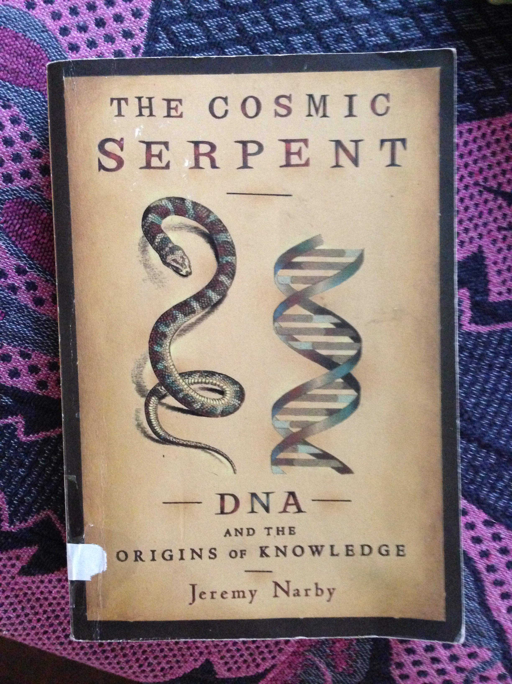
The Cosmic Serpent,
Jeremy Narby

the focus are the yellow paintings, a video projection installation in the main room and a publication that can also be available online in a PDF. I will work on this soon as I'm back in town.

I'm glad you like reino abstrato as central piece, there are three of them reino abstrato VI, VII and VIII 40 x 40 cm I want to show.
they are going to be next to each other in the wall with the mp3 sound piece playing in the room (could be a sound speaker in a pedestal as a sculpture)

the photographs will follow text of madelon and my introduction in the pdf publication

pricelist:

paintings US$ 3.320,00
drawings US$ 1.500,00
sound piece US$ 1.000,00
video US$ 2.000,00

Concerning the works you still have, I would please request If you could sell them during the show. They can be somewhere in the second flor and you explain they are from the previous show. It would be amazing. If not, I would be more then happy to show then in a solo booth at Arco or SP-Arte next year mixed with new works. I spoke to luiza teixeira de freitas and she's going to do it again next year apparently or we do any other art fair. I can play with then around on how to display. It can work for sure.

Please, could you list the works you do still have? I know there are the 3 paintings, 3 taboms and the bronze piece. I think you should still try to sell the Taboms, this work is featured in the historias mestiças catalogue and the Tabom sculpture is featured in another 2 catalogues (Bienal do Mercosul and Pipa Prize)Historias Mestiças catalogue is sold out but I can scan the cover and the pages where the works are featured also with a paragraph about them by Adriano Pedrosa. It's 4 pages!

This series of paintings explores the tension between representation and abstraction. An ambiguity between the painterly figurative and the photographic device. The geometric patterns of Moroccan stone pavements are captured, as a stand up snapshot and after being painted resembles aerial views of an abstract landscape. The lexicon of abstraction is embedded then through the painting of real places. The subject is the Jamaa el Fna Square, a market place in Marrakesh’s medina. During the day it is predominantly occupied by orange juice stalls, youths with chained Barbary apes, water sellers in colourful costumes with traditional leather water-bags and brass cups as well as snake charmers who will pose for photographs with tourists. It remains the main square of Marrakesh and is used by locals and tourists. It’s open 24 hours a day, 7 days a week. A continous market loop happening on top of this abstract pavement.

http://blog.theparliamentofthings.org/about/

Yet, the dawn of the anthropocene and our growing awareness of the need for a more equal relation with our environment seem to have lead to a willingness to consider other, perhaps less conventional, theories on nature. Our idea of nature stems from a western perspective, but slowly interest in a more plural In How Forests Think. Towards an Anthropology beyond the Human (2013) the Ecuadorian anthropologist Eduard Kohn for example seriously considers the validity of to us unknown and sometimes improvable communication systems and forms of intelligence present in forests as well.

Email Rodrigo García Dutra xxx
Interview Rodrigo García Dutra. PIPA 2016. Artist nominees via
Neo concrete video
Kohn’s research served as an important source of inspiration for Forest Law, a series of legal cases in which is plead for the rights of nature.

